**What is AWS DynamoDB?**

* DynamoDB is a fast and flexible NoSQL database designed for applications that need consistent, single-digit millisecond latency at any scale.it is a fully managed database and it supports both document and key value data models.

*A document-oriented database, or document store, is for storing, retrieving, and managing document-oriented information, which is semi-structured data.. Key- value store is inherit of Document Oriented database. The difference lies in the way the data is processed; in a key-value store the data is considered to be inherently opaque to the database, whereas a document-oriented system relies on internal structure in the document in order to extract metadata that the database engine uses for further optimization.

* It has a very flexible data model. This means that you don't need to define your database schema upfront. It also has reliable performance.

DynamoDB Tables

DynamoDB tables consist of

* Items (Think of a row of data in a table).
* Attributes ((Think of a column of data in a table).
* Supports key-value and document data structures.
* Key= the name of the data.  Value= the data itself.
* Document can be written in JSON, HTML or XML.

DynamoDB- Primary Keys

* DynamoDB stores and retrieves data based on a Primary key
* DynamoDB also uses Partition keys to determine the physical location data is stored.
* If you are using a partition key as your Primary key, then no items will have the same Partition key.
* Composite Keys (Partition Key + Sort Key) can be used in Combination.
* Two items may have the same partition key, but must have a different sort key.
* All items with the same partition key are stored together and then sorted according to the sort key value.
* DynamoDB allows you to store multiple items with the same partition keys.

# ****Architecture Diagram****

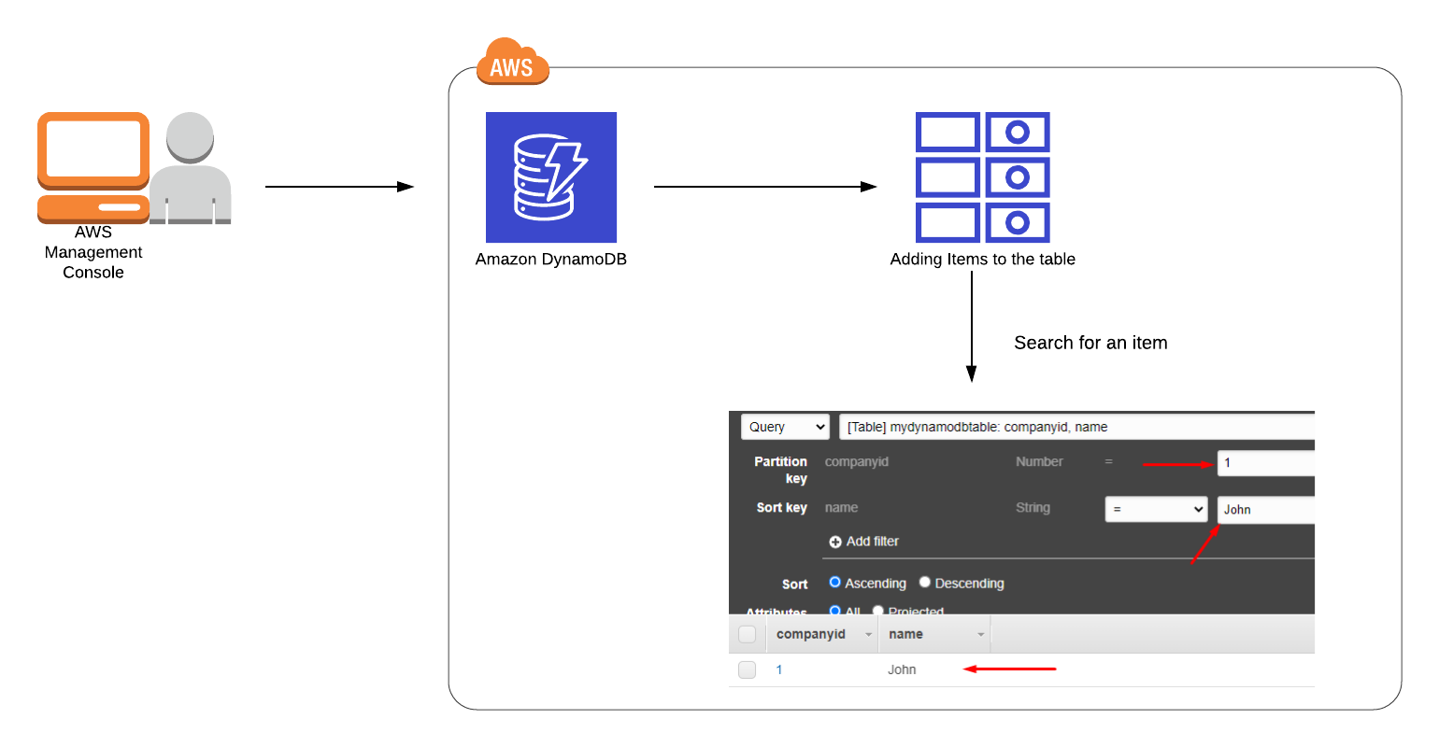

# ****Lab Steps****

## ****Task 1: Sign in to AWS Management Console****

1. Click on the **Open Console** button, and you will get redirected to AWS Console in a new browser tab.
2. On the AWS sign-in page,

* Leave the Account ID as default. Never edit/remove the 12-digit Account ID present in the AWS Console. Otherwise, you cannot proceed with the lab.
* Now copy your **Username** and **Password** in the Lab Console to the **IAM Username and Password** in AWS Console and click on the **Sign-in** button.

1. Once Signed In to the AWS Management Console, make the default AWS Region as **US East (N. Virginia) us-east-1.**

## ****Task 2: Create DynamoDB Table****

In this task, we are going to create a DynamoDB table.

1. Make sure you are in the **US East (N. Virginia) us-east-1** Region.
2. Navigate to **DynamoDB** page by clicking on the **Services** menu at the top. DynamoDB is available under the **Database** section.
3. Click on **Create table**button

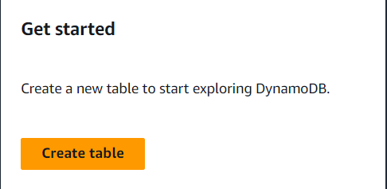

* Table Name: Enter **mydynamodbtable**
* Primary key: Enter **companyid** and select **Number**
* Add sort key: Enter **name** in the respective field and select **String**.

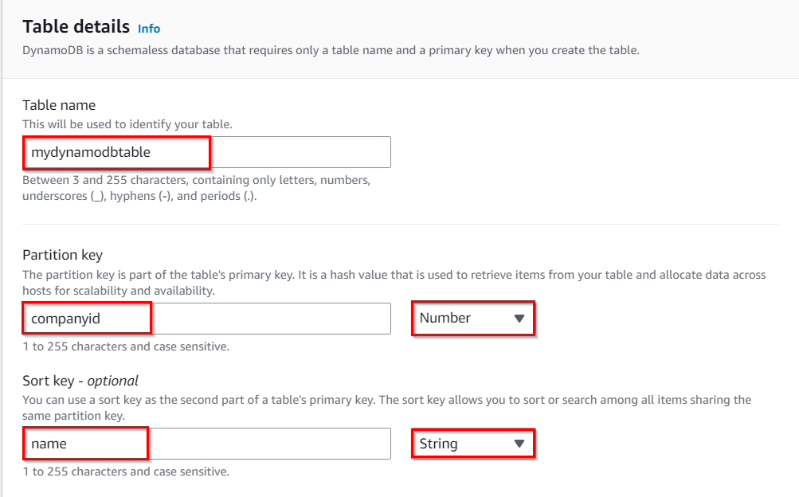

* The combination of a Primary Key and a Sort Key uniquely identifies each item in a DynamoDB table.
* Leave all the other settings as default and then click on **Create table**.

1. Your table will be created within 2–3 minutes.

**Task 3 : Inserting Data into DynamoDB Table**

In this task, we are going to insert data into a DynamoDB table. By adding data to the table, we will understand how to populate it with relevant information.

1. Next, we are inserting data in the table we created.
2. Select **mydynamodbtable** and then Click on the **Explore table items**button.

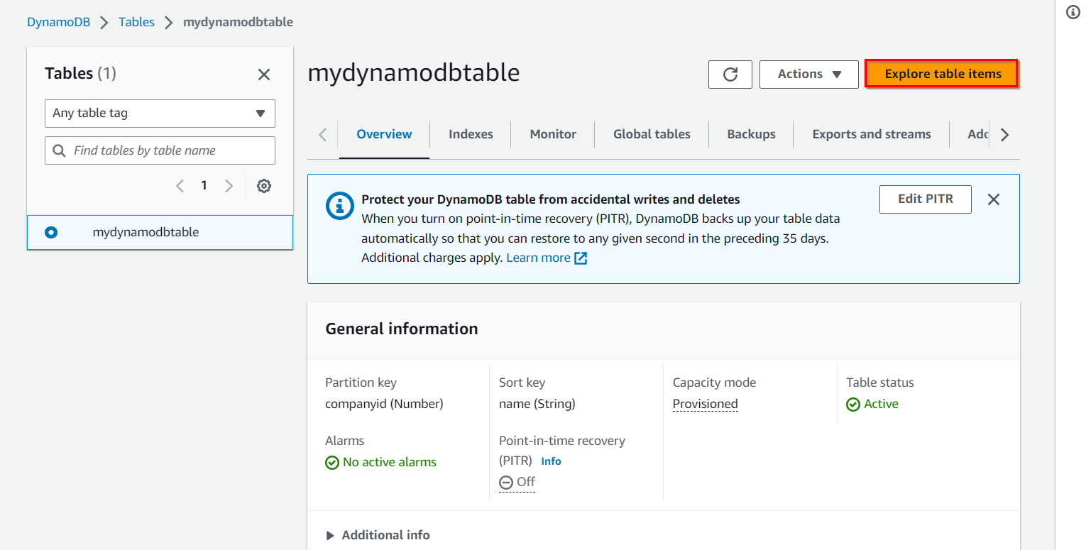

1. Now click on **Create item** button.

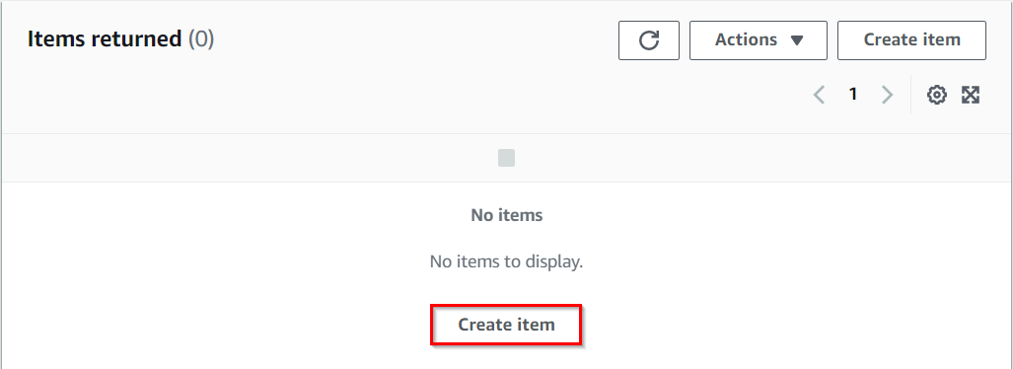

1. Add new primary key and sort key values.
   * companyid     : Enter **1**
   * name        :Enter **John**
2. After entering the data, click on the **Create item** button, present on the right bottom corner.
3. For testing purposes, add 4–5 items as shown in the above step and click on the **Create item** button.

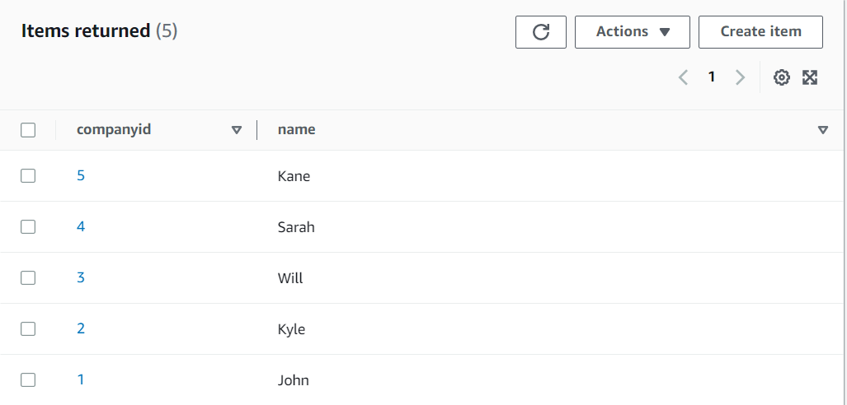

**Task 4 : Search for Items in the Table**

In this task, we are going to query capabilities of DynamoDB. By using the scan operation.

1. We will query the items in our table by using **scan**.
2. Select **Query**

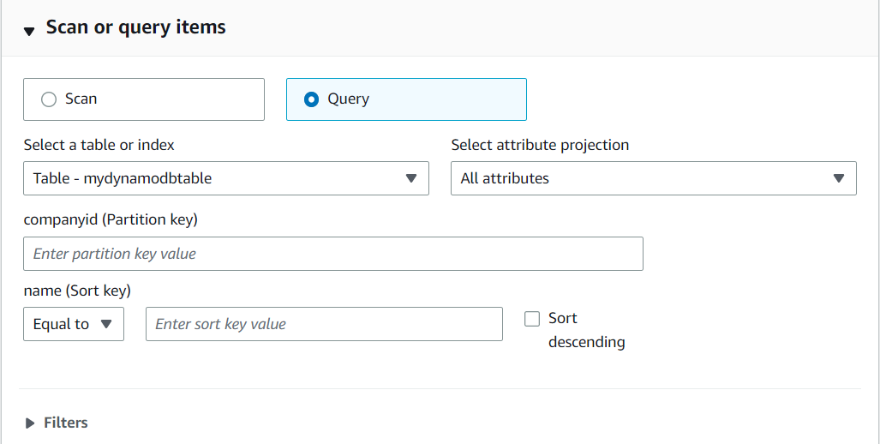

1. In the query window, enter the partition key and sort key which you want to search.
   * Partition Key = Enter **4**
   * Sort Key = Enter **Sarah**
   * Click on **Run**.
2. You will be able to see a result table with your filtered records. A sample screenshot is given below:



1. You can search with the Partition Key and the Sort Key. Try some additional test cases yourself to become more familiar with these keys.

### ****Do You Know?****

DynamoDB was originally developed by Amazon to meet the demands of their e-commerce platform during the holiday shopping season. The system needed to handle the sudden spike in traffic and maintain low latency for a large number of concurrent users. DynamoDB's design principles and scalability were tested and proven in this high-stakes environment, ensuring its reliability and performance even under extreme load conditions.